NOTICE TO RESIDENTS

FOOTPATH WORKS ZURICH ROAD, CRAIGMORE

The City of Playford is pleased to inform you that footpath renewal works on Zurich Road, Craigmore are about to commence as part of Council’s Capital Works Program. This work involves the renewal and widening of the existing footpath, as well as the upgrade of kerb ramps for accessibility compliance. Parisi Paving have been contracted by Council to complete this works.

When will work start?

Work in your street will commence on 5 / 1 / 26 and is expected to be completed on the 19 / 01 / 26. Inclement weather may delay the scheduling of these works.

How will this affect me?

Footpaths may also be closed to pedestrians during construction but will be reopened once completed. Parisi Paving will work with residents to ensure there is as little inconvenience as possible.

We will work with the waste collection contractor to ensure rubbish bins are accessible and collected on your regular collection days. Our crew will assist in relocating bins to a suitable pick-up location and returning them afterward.

Can we please ask that all vehicles are not parked on verges or footpaths during the construction period. This will help ensure the safety of workers and allow works to proceed without delay.

Traffic control signs and speed restrictions will be in place to ensure the safety of pedestrians and motorists.

If you have any queries, please do not hesitate to contact the Parisi Paving representative on the number below. We apologise for any inconvenience caused during the course of this work and thank you in advance for your understanding and cooperation.

Yours sincerely,

Liber Milans

Supervisor


Phone: (08) 8252 0187
Email: liber@parisipaving.com.au

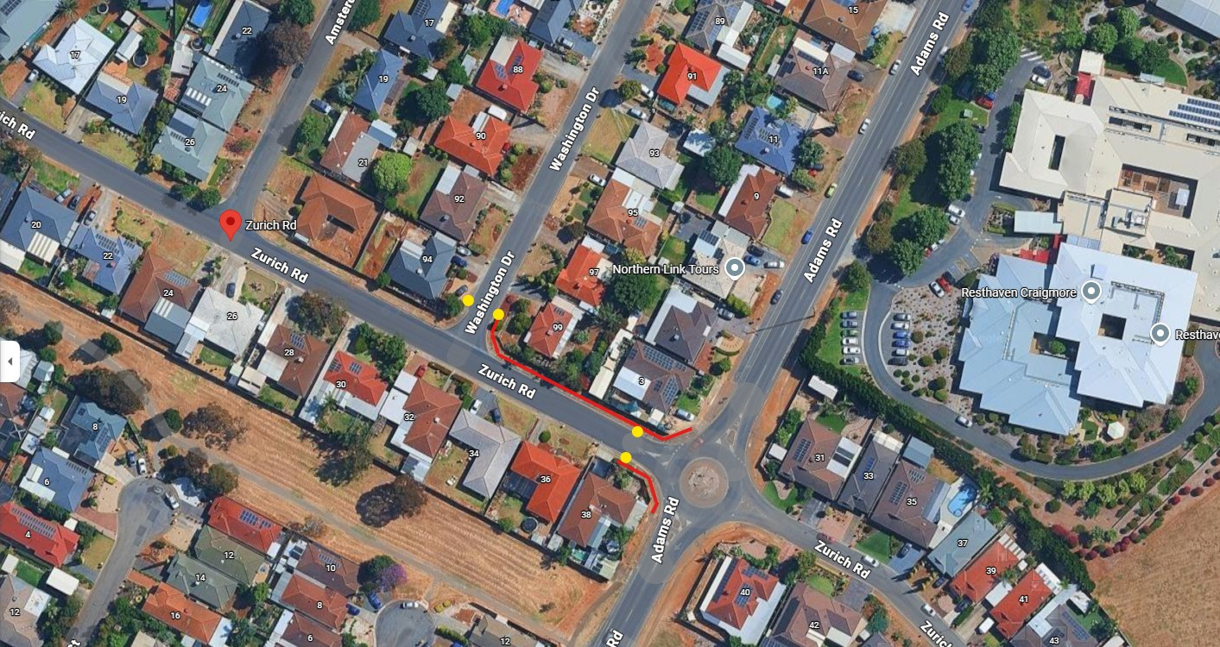

Footpath

Pram Ramp

