22/01/2026
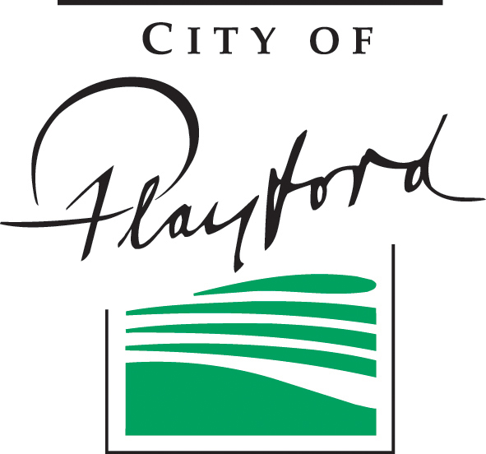

Dear Resident / Business Owner

Remo Contractors Pty Ltd, on behalf of the City of Playford, will shortly commence kerb and gutter upgrade works along Boronia Crt, Craigmore as part of the 2025–2026 City of Playford Road Reseal Program. These kerb and gutter works will be completed before road resealing to improve stormwater drainage and help extend the life of the new road surface.

Work in this area is scheduled to commence from the week of the 02/02/2026 and is expected to take approximately 15 business days (weather permitting).

Work will be undertaken during the hours of 7am to 5pm, Monday to Friday.

The affected work areas will be subject to standard work zone traffic management. Road closures and speed restrictions may apply.

There may be some restrictions to your driveway access during the works.

We apologise for any inconvenience caused and thank you for your patience.

If you have any concerns, please contact Tony Moritz on 0421 932 771 or Jack collard on 0429 371 790

For after-hours emergencies, please contact 8252 7240 (and leave message) if mobile numbers are not available.

Yours sincerely

Jack Collard
Operations Manager


