30/04/2025

Dear Resident / Business Owner

WORKS NOTIFICATION

Remo Contractors Pty Ltd will soon be upgrading the kerb and gutter and stormwater work on Shelter Close, Sanctuary Walk and Corella Drive, Blakeview.

Work in this area is scheduled to commence from the 05/05/2026 and is expected to take approximately 20 business days (weather permitting).

Work will be undertaken during the hours of 7am to 4pm, Monday to Friday.

The affected work areas will be subject to standard work zone traffic management. Road closures and speed restrictions may apply.

There may be some restrictions to your driveway access during the works.

We apologise for any inconvenience caused and thank you for your patience.

If you have any concerns, please contact Jack Collard on 0429 371 790 or Tony Moritz on 0421 932 771

For after-hours emergencies, please contact 8252 7240 (and leave message) if mobile numbers are not available.

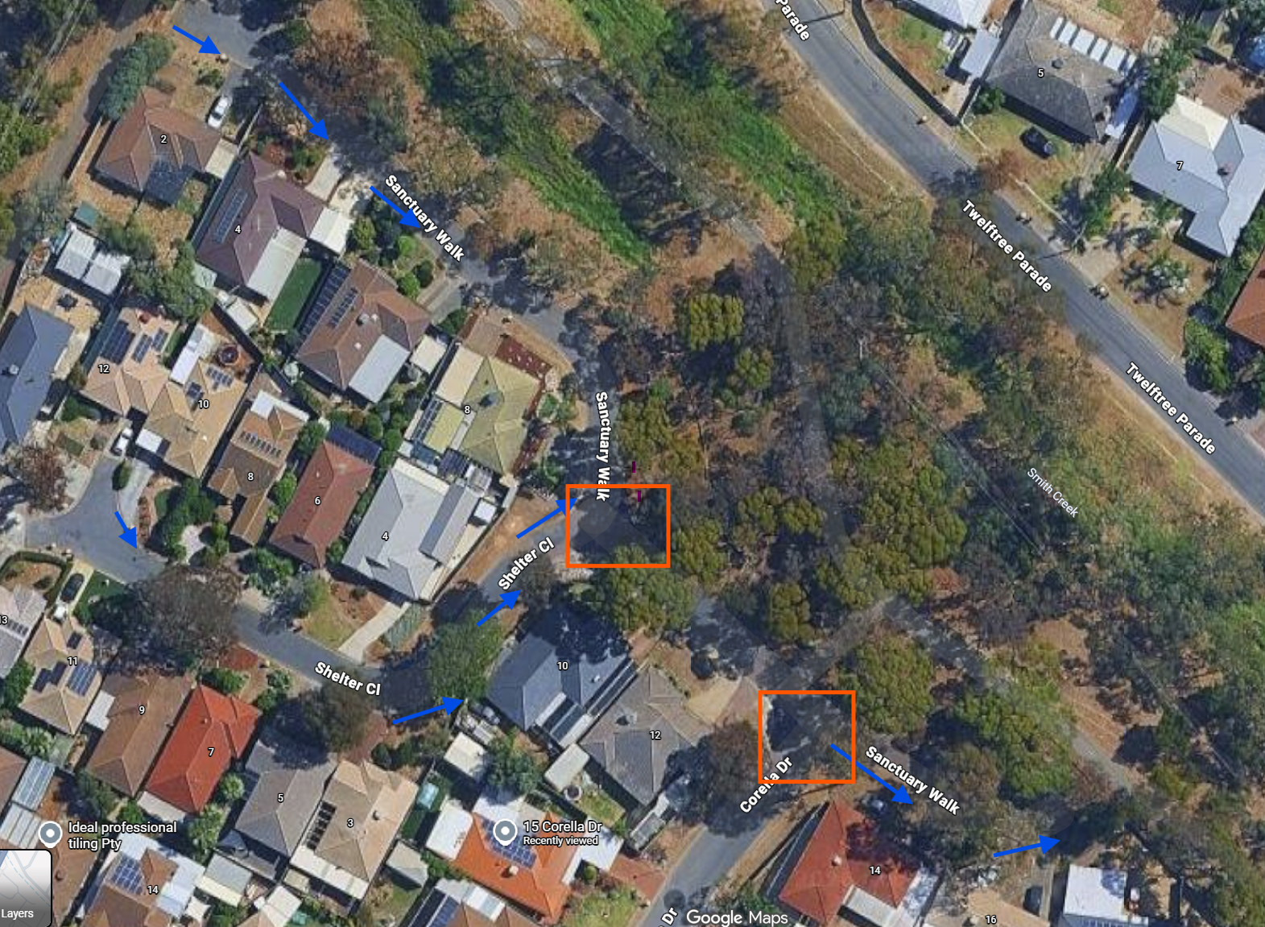

Pic: Tentative catchment areas of work (Blue arrow- Kerb & Gutter , Red Rectangle- Stormwater work)

Yours sincerely

Jack Collard
Operations Manager

